## RDS Team Dynamics *Bi-Weekly Update*

**Assignment Goals / Deliverables:** Continuing the theme set with our first Team Dynamics assignment, we want you to get together with your team for a social activity either in-person or virtually (whichever you feel comfortable with). You can share a meal together, play a game, or something along those lines. This gathering should help you unwind a little, and allow you to reflect upon how your team has been performing over the last two weeks. As deliverables, we ask that you complete the following two tasks and upload them to the Canvas assignment:

* Take a photo / screenshot of your group at your gathering.
* Answer the questions below as a group.

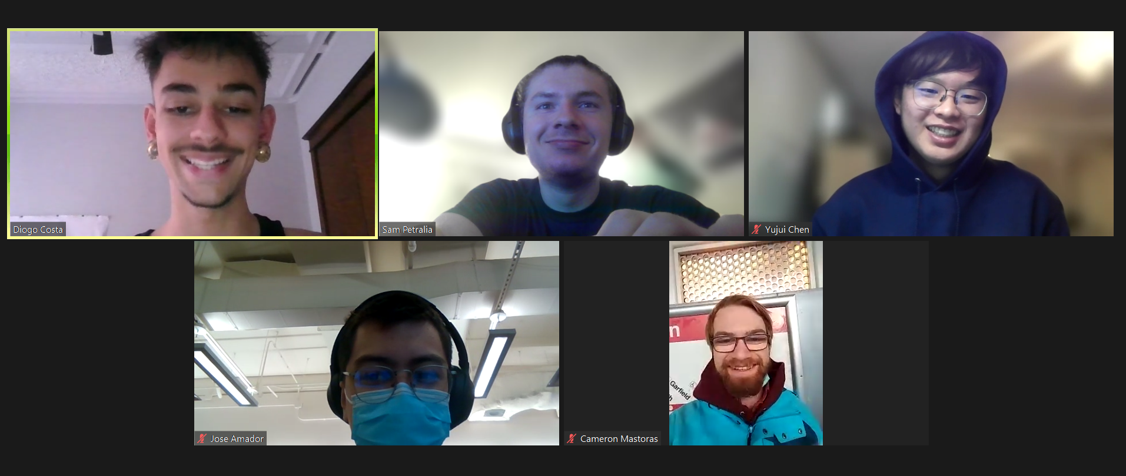

***Please be open and honest with yourselves and your group. There will be no penalties for the answers you provide in these bi-weekly updates, rather they should help you find areas for potential growth and help you recognize individual and team development.***

1. Have there been any conflicts or issues that have arisen within your team over the last two weeks? If so, what were they, and how were they resolved?

| There were no major conflicts in the group thus far, any disagreements that happened were over technical issues. For example, we disagreed on how we should incorporate magnets into either the mechanism or actuator teams and when we should start working with them. We solved this by making it a point to discuss it during our time with Professors Colgate and Strong during our meeting with them, and we were all able to get on the same page. |
| --- |

1. Are there any conflicts or issues within your team that are still outstanding that you would like to discuss during your next weekly meeting?

| Not so far! |
| --- |

1. Are there any areas where you feel your team is excelling?

| We think our team has been excelling in having creative and innovative discussions about the technical parts of the tablet problem. Everyone has been bringing cool ideas, and there’s been lots of great back and forth between everybody doing things like combining ideas or modifying ideas. As a result, we think we have a very large collection of possible solutions and solution archetypes upon which we can draw as we move into the prototyping phase. |
| --- |

1. Are there any areas where you feel your team needs improvement?

| We think our team organization thus far has been adequate for this stage of the project, as it has been mostly brainstorming together and discussing ideas. However, as we move into the prototyping and building phase, there will be much more parallel/separate work. We want to improve upon organization, particularly time efficiency, during meetings so we can quickly address any issues and solve them together without wasting time figuring out what they are. The plan is to come to team meetings prepared with stuff so we can tackle it quickly and efficiently during team meetings, which will mean taking advantage of the agenda more.  Furthermore, we also want to improve our communication with the Professors as well, as we think it will be important to keep a really tight feedback loop between them. We don’t want to lose a few days here and there waiting around for our weekly meeting with them, as that is a lot of time for the project.  Lastly, we also want to plan out more social events further in advance so we can come together as a group more as well. |
| --- |